Filed by Bleichroeder Acquisition France Merger Sub 2 pursuant to Rule 425
under the Securities Act of 1933, as amended,
and deemed filed pursuant to Rule 14a-12
under the Securities Exchange Act of 1934, as amended
Subject Company: Pasqal Holding SAS (File No. 333-296239-01)

The following is a LinkedIn post published on August 6, 2026 by Pasqal Holding SAS.

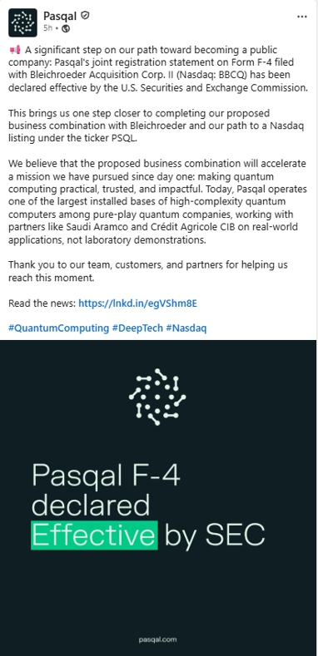

***

Forward-Looking Statements

Certain statements herein may be considered “forward-looking statements” within the meaning of Section 27A of the Securities Act of 1933, as amended, and Section 21E of the Securities Exchange Act of 1934, as amended. Forward-looking statements generally are accompanied by words such as “believe,” “may,” “might”, “will,” “estimate,” “continue,” “anticipate,” “intend,” “expect,” “should,” “would,” “could,” “plan,” “predict,” “project”, “forecast,” “believe,” “potential,” “seem,” “seek,” “target,” “possible,” “future,” “outlook” or similar terminology or expressions that predict or indicate future events or trends. These forward-looking statements include, but are not limited to, statements regarding future events and the proposed business combination between Bleichroeder Acquisition Corp. II (“Bleichroeder”) and Pasqal Holding SAS (“Pasqal”).

These statements are based on current expectations and are not predictions of actual performance. They are provided for illustrative purposes only and must not be relied on as a guarantee, prediction or definitive statement of fact or probability. Actual events and circumstances are difficult or impossible to predict and are beyond the control of Bleichroeder and Pasqal. These statements are subject to known and unknown risks, uncertainties and assumptions regarding Pasqal’s business and the business combination, and actual results may differ materially. These risks and uncertainties include, but are not limited to: general economic, political, social and business conditions; uncertainty or changes with respect to laws and regulations; the inability of the parties to consummate the business combination failure to realize the anticipated benefits of the business combination; the risk that the business combination disrupts Pasqal’s current plans and operations; the risk from Pasqal pursuing an emerging technology, facing significant technical challenges and the potential that it may not achieve commercialization or market acceptance; Pasqal’s reliance on strategic partners and other third parties; Pasqal’s ability to maintain, protect and defend its intellectual property rights; and other risks that will be detailed from time to time in filings with the U.S. Securities and Exchange Commission (the “SEC”). The foregoing list of risk factors is not exhaustive. There may be additional risks that Pasqal and Bleichroeder presently do not know or currently believe are immaterial that could also cause actual results to differ from those contained in forward-looking statements. In addition, forward-looking statements provide Pasqal’s and/or Bleichroeder’s expectations, plans and forecasts of future events and views as of the date of this communication. While Pasqal and/or Bleichroeder may elect to update these forward-looking statements in the future, Pasqal and Bleichroeder specifically disclaim any obligation to do so.

Additional Information and Where to Find It

The business combination will be submitted to shareholders of Bleichroeder for their consideration. In connection with the business combination, Bleichroeder, Bleichroeder Acquisition France Merger Sub 2 and Pasqal jointly filed a registration statement on Form F-4 with the SEC, which was declared effective by the SEC on August 5, 2026 (as subsequently amended, the “Registration Statement”), and which includes a definitive proxy statement/prospectus. The definitive proxy statement/prospectus and certain other related documents have been mailed to Bleichroeder shareholders as of August 4, 2026, the record date established for voting on the proposed transaction, in connection with Bleichroeder’s solicitation for proxies for the vote by Bleichroeder’s shareholders in connection with the business combination and other matters described in the Registration Statement, as well as the prospectus relating to the offer and sale of the securities to be issued to Pasqal’s shareholders in connection with the completion of the business combination. This communication is not a substitute for the Registration Statement, the definitive proxy statement/prospectus or any other document that Bleichroeder has sent to its shareholders in connection with the business combination.

2

BEFORE MAKING ANY INVESTMENT OR VOTING DECISION, INVESTORS AND SECURITY HOLDERS ARE ADVISED TO READ THE REGISTRATION STATEMENT, DEFINITIVE PROXY STATEMENT/PROSPECTUS AND ANY OTHER RELEVANT DOCUMENTS AND, IN EACH CASE, ANY AMENDMENTS THERETO, FILED WITH THE SEC CAREFULLY AND IN THEIR ENTIRETY AS AND WHEN THEY BECOME AVAILABLE BECAUSE THEY WILL CONTAIN IMPORTANT INFORMATION ABOUT THE BUSINESS COMBINATION, RELATED TRANSACTIONS AND THE PARTIES TO THE BUSINESS COMBINATION. Shareholders of Bleichroeder may obtain copies of these documents (when available) and other documents filed with the SEC free of charge at www.sec.gov.

Participants in the Solicitation

Bleichroeder, Pasqal and certain of their respective directors, executive officers, and other members of management, employees and consultants, under SEC rules, may be deemed participants in the solicitation of proxies from Bleichroeder’s shareholders with respect to the business combination. A list of the names of Bleichroeder’s directors and executive officers and a description of their interests in Bleichroeder and the business combination is contained in the sections entitled “Directors, Executive Officers and Corporate Governance,” “Security Ownership of Certain Beneficial Owners and Management and Related Stockholder Matters,” and “Certain Relationships and Related Transactions, and Director Independence” of the Annual Report filed by Bleichroeder with the SEC on March 16 2026 and the Current Report on Form 8-K filed with the SEC on May 1, 2026, each of which is available free of charge at the SEC’s website at www.sec.gov. Information regarding the persons who may, under SEC rules, be deemed participants in the solicitation of proxies from Bleichroeder’s shareholders with respect to the business combination, and their direct and indirect interests, is included in the Registration Statement and the proxy statement/prospectus.

No Offer or Solicitation

This communication is for informational purposes only and is not (i) an offer to purchase, nor a solicitation of an offer to sell, subscribe for or buy any securities, nor shall there be any sale, issuance or transfer of securities in any jurisdiction in contravention of applicable law nor (ii) the solicitation of any vote in any jurisdiction pursuant to the business combination or otherwise. No offer of securities shall be made except by means of a prospectus meeting the requirements of Section 10 of the Securities Act of 1933, as amended, or exemptions therefrom. No securities commission or securities regulatory authority has in any way passed upon the merits of the business combination or the accuracy or adequacy of this communication.

3

